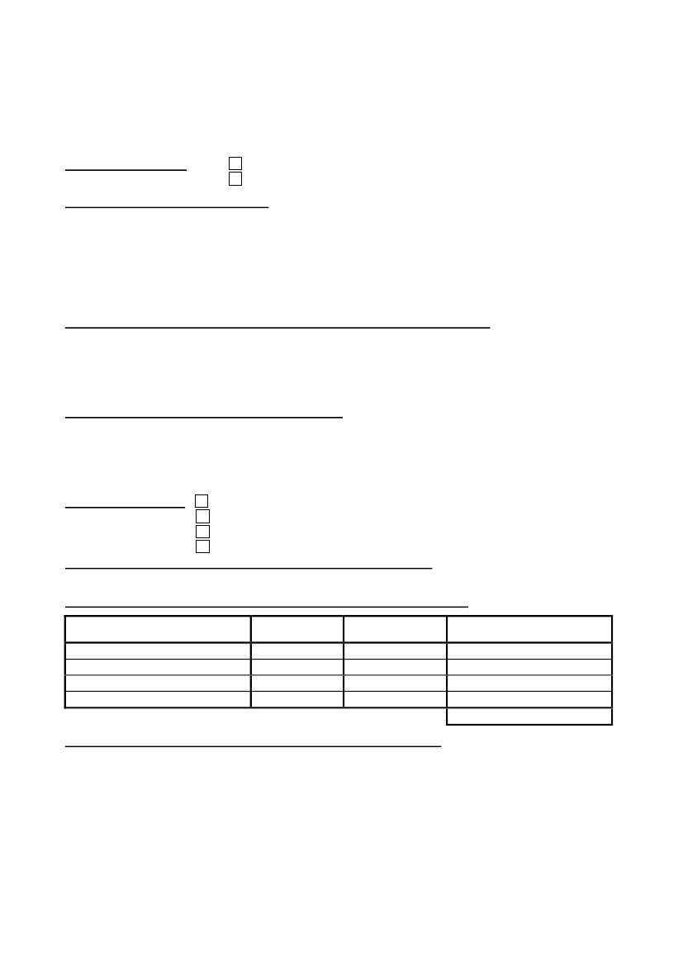
Declaration made to the competent Monegasque authorities pursuant to Article 35 of Act 1362 of 3 August 2009
on the fight against money laundering, terrorist financing and corruption
Explanatory note overleaf
---
DECLARATION CONCERNING THE TRANSPORT OF CASH AND BEARER
INSTRUMENTS FOR A TOTAL VALUE EXCEEDING EUR 10,000-
---
Department of Finance and the Economy
Type of declaration:
Arrival in the Principality of Monaco
Leaving the Principality of Monaco
Person making the declaration1:
Surname: ……….………..………............................... First name: ……...........................................
Date of birth: .... / .... / ........Place of birth: ……............................................
Nationality: ……............................. Passport number: ……........................
Main address: ……….………..………............................……………………………………….…………………….
…………………………………….………..………............................……………………………….…………………….
…………………………………….………..………............................……………………………….…………………….
Instructing party (in the case of transfers on behalf of a third party)2: are
Surname or Business name: …….………..………............................. First name: ….........................
Main address or Registered office: ……….………..………....................….………………….………………….
…………………………………….………..………............................…………………………………..………………….
…………………………………….………..………............................……………………………………..……………….
Beneficiary of cash and bearer instruments3:
Surname or Business name: …………..………............................. First name: …...........................
Main address or Registered office: ……….………..………....................….…………………………………...
…………………………………….………..………............................…………………………………………………….
…………………………………….………..………............................…………………………………………………….
Air – Flight n° ………………….
Sea - Name of vessel: ………….……………..…. Flag: ….……….………...
Road - Vehicle registration: ….……….…………..…….………………….
Train - Train number: ………….……………

Itinerary for the transport of cash and bearer instruments:
Country of departure: ……............................. Country of destination: …….............................
Nature and amount of cash and bearer instruments transported4:
Type (cash, cheques, other bearer
instruments)
Currency
Amount
Exchange value in euros
Means of transport:
TOTAL:
Source and use of cash and bearer instruments transported:
Financial provenance5:……….…….………..………...................….……………………………………………….
Intended use6: ……………………….………..………....................….……………………………………………….
…………………………………….………..………............................……………………………………………………
I the undersigned declare that I am the bearer of the sums, instruments or securities listed above. This is a
full and precise declaration. The obligation to make a declaration shall not be considered to have been
fulfilled if the information provided is incorrect or incomplete. Any non-declaration, incorrect or incomplete
declaration shall be subject to the penalties described in Article 42 of Act 1362 of 3 August 2009 on the fight
against money laundering, terrorist financing and corruption.
Declaration made in ……............................., on .... / .... / ........
Signature

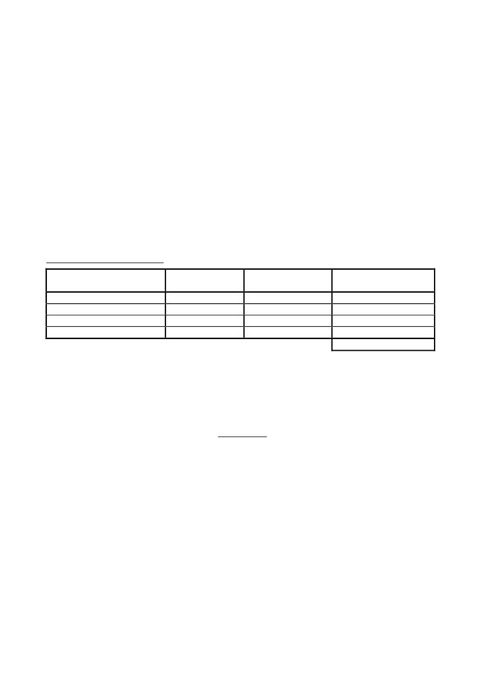
EXPLANATORY NOTE
1
The person concerned is the natural person making the declaration, i.e. the natural person who
is transporting the cash and bearer instruments.
Do not complete if the transfer is on your own behalf.
The beneficiary of the cash and bearer instruments is the natural or legal person to whom this
cash and these bearer instruments are to be given, whether as part of a commercial transaction
or not. If this person is unknown, indicate “not yet known”. If the person declaring is keeping the
cash and bearer instruments, they shall indicate their name a second time.
By “bearer instruments” is meant negotiable bearer instruments such as travellers’ cheques,
negotiable instruments (including cheques, promissory notes and money orders) either made out
to the bearer, or endorsed without restriction, or established to the order of a fictitious
beneficiary or presented in any other form such that the ownership of the instrument is assigned
when it is transferred, and incomplete instruments (including cheques, promissory notes and
money orders) that are signed but upon which the name of the beneficiary has not been
indicated.
Type (cash, cheques, other
bearer instruments)
Cash
Cash
Travellers’ cheques
2
3
4
Example of a completed table:
Currency
EUR
USD
EUR
Amount
7,500-
3,000-
2,000-
TOTAL:
5
Exchange value in euros
7,500-
2,300-
2,000-
11,800-
This point concerns financial provenance, not geographical provenance. For example: savings,
inheritance, proceeds of a sale, working capital, etc.
For example: purchase, payment of a service, etc.
6
IMPORTANT
If you have any questions or you have difficulties completing this form, please ask for
information from authorized agents before handing in your signed declaration.
The lodging of this declaration with the Monegasque authorities does not exempt you
from any obligation of declaration in the State where you are going.

